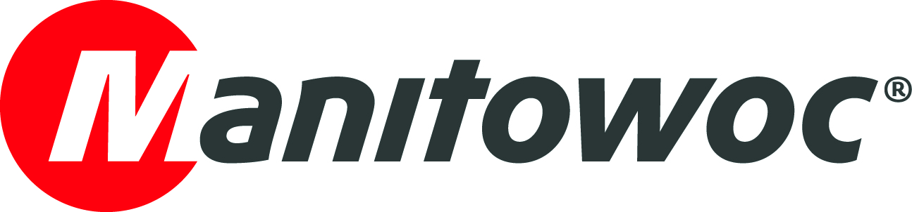
CAPTION RELEASE

April 8, 2019

Potain and Stirnimann celebrate the success of the new Hup C 40-30 at bauma 2019

The new Potain Hup C 40-30 is unique to Manitowoc’s Potain self-erecting tower crane line. This crane is from the groundbreaking Hup range and is enhanced with crawler tracks for ultimate mobility on job sites with challenging terrain (hence the “C” in the model’s name).

At bauma 2019 in Munich, Germany, representatives from Potain and Stirnimann celebrated the crane’s success. The two companies collaborated to develop the crane, and Stirnimann has since purchased six of them. During a champagne toast at the Manitowoc Cranes booth, Reudiger Boeck, director of sales for Potain tower cranes in central Europe, presented Stirnimann with an award for its efforts.

“We want to thank Stirnimann for its commitment to helping Potain develop the Hup C 40-30,” Boeck said. “Stirnimann invested significant time and effort into providing real-world feedback that influenced the ultimate design of this unique self-erecting crane. This type of collaboration is The Manitowoc Way in action.”

-END-

CONTACT
Amy Marten
Manitowoc
T +1 920 683 6345
amy.marten@manitowoc.com

ABOUT THE MANITOWOC COMPANY, INC.
Founded in 1902, The Manitowoc Company, Inc. is a leading global manufacturer of cranes and lifting solutions with manufacturing, distribution, and service facilities in 20 countries. In the United States, the Grove, Manitowoc, National Crane, Potain and Shuttlelift brands are sold and serviced by Grove US, LLC, a wholly owned subsidiary of The Manitowoc Company, Inc. In 2018, Manitowoc’s net sales totaled $1.8 billion, with over half generated outside the United States.

THE MANITOWOC COMPANY, INC.
One Park Plaza – 11270 West Park Place – Suite 1000 – Milwaukee, WI 53224, USA
T +1 920 684 4410
www.manitowoc.com

